Change how you get 2-step verification codes
Depending on how your Office 365 admin set up 2-step verification for your organization, you might be able to change how you get your codes.
- Sign in to Office 365 using your password and verification code.
- Choose Settings > Office 365.
- Choose Security & Privacy > Additional security verification.
- Choose Update my phone numbers used for account security. This will display the following page:
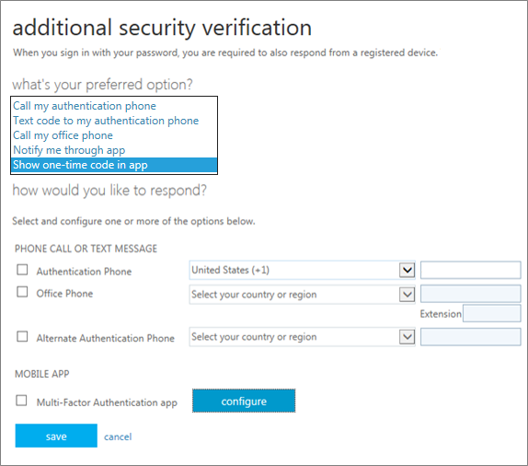
- Choose how you want to get your verification code. Although all options are listed, your admin may not make them all available; you'll get a message if you choose one your admin didn't enable.
- Follow the prompts on the page.
- We strongly recommend setting up more than one verification method. For example, if you travel a lot, consider setting up Microsoft Authenticator for your verification method. It's the easiest verification method to use, and a way to avoid text or call charges. You can download the “Microsoft Authenticator” app in your devices app store.

